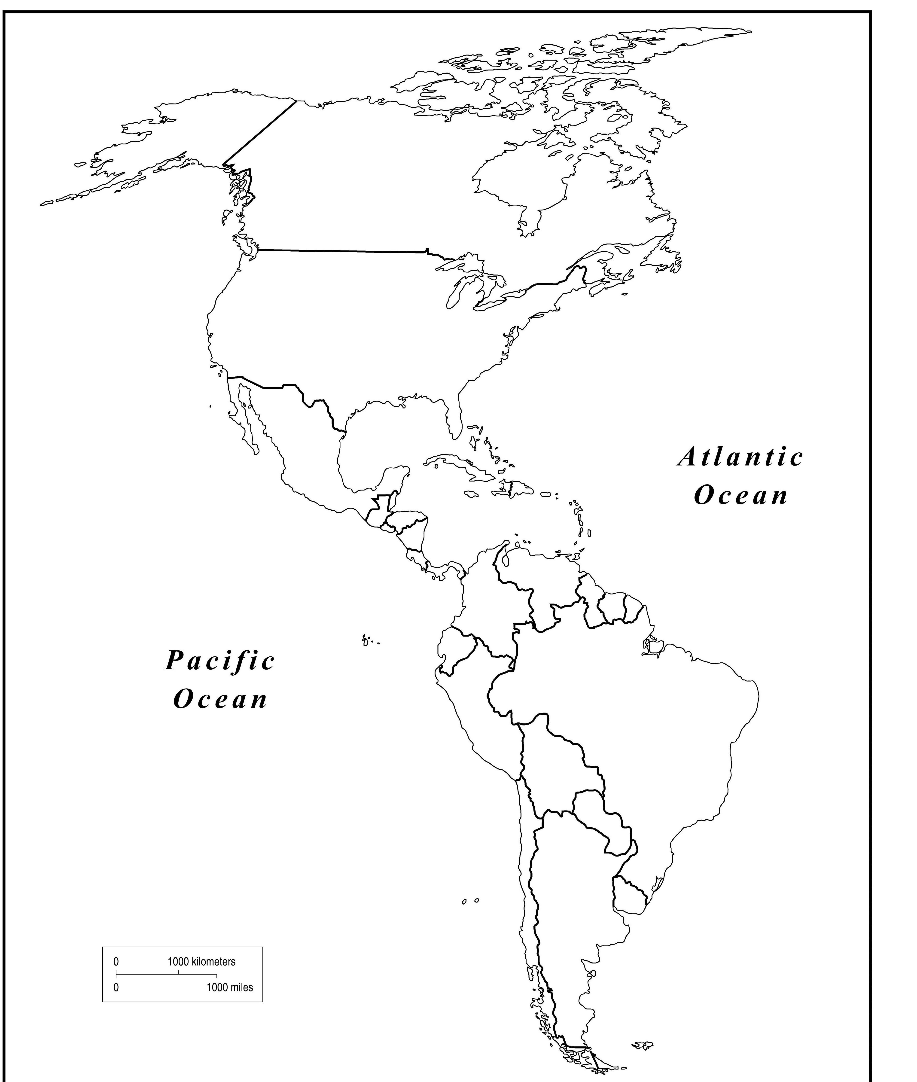
Name:
Why is geography important to our study of history?
Use the different map selections in the
atlas to locate and label the following
items on the world maps hand-outs.

- 7 Continents
- Equator
- Atlantic Ocean
- Pacific Ocean
- Arctic Ocean
- Indian Ocean
- Ural Mountains (Urals)
- Nile River
- Sahara Desert
- Caspian Sea
- Black Sea
- Mediterranean Sea
- Red Sea
- Bering Sea
- Persian Gulf
- Arabian Peninsula/ Arabia

- Gulf of Mexico
- Amazon River

- Andes Mountains
- Russia
- Spain
- Italy
- Greece
- Turkey (Asia Minor)
- India
- China
- Japan
- Iraq
- Egypt
- Mexico
